Client stuff

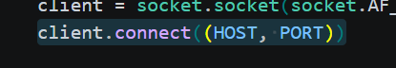
This line Establishes TCP connection with server and is used to become part of the chat network
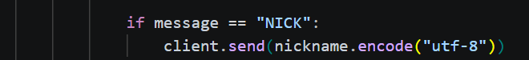
This line is the username setup
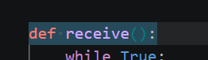
This line allows it to Continuously look for incoming messages it also allows the printing of messages in the terminal

This is how you message the other user it takes the input from your keyboard and sends it to the server.

Server stuff
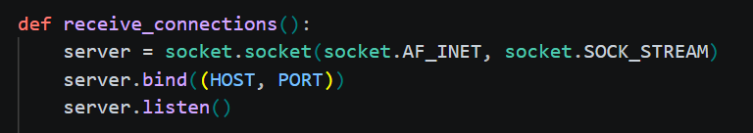
This creates a TCP socket and binds it to a local IP and port. It also starts listening for incoming client connections
This waits for a new client to connect it Accepts the connection and creates a socket for that client.

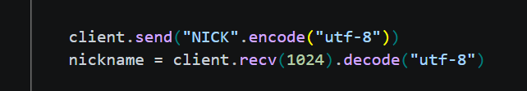
This is how the server asks a client for a username and it stores it for identification to see who is sending chat messages
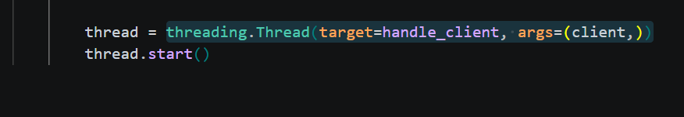
This creates a new thread for each client and it allows multiple clients to talk at the same time.
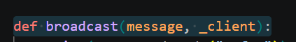
This sends incoming messages to all the connected clients it does not send it to the person who is sending the message to prevent echo duplication

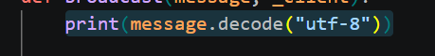
This allows the server to display messages between the clients

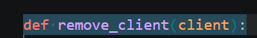
This handles client disconnection it closes the socket and notifies the other users that someone left

Step by step execution
The server starts and listens on port
The clients connect to the server
Then the server asks the client for a nickname
The clients then send a nickname
The server stores the clients then creates a thread
Client then sends a message
Server receives the message
Server prints message
Server broadcasts message to all clients
All clients receive and display message

